**2. Reactjs-HOL**

Question:- Create a react app for Student Management Portal named StudentApp and create a component named Home which will display the Message “Welcome to the Home page of Student Management Portal”. Create another component named About and display the Message “Welcome to the About page of the Student Management Portal”. Create a third component named Contact and display the Message “Welcome to the Contact page of the Student Management Portal”. Call all the three components.

**Step 1.** Create the react app named StudentApp by the following command

**“npx create-react-app StudentApp”**

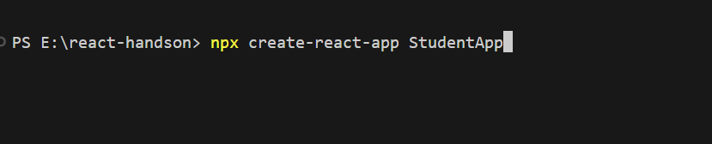

You may face this error

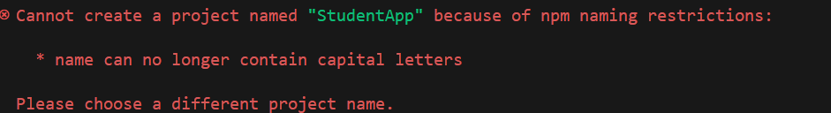

So instead try with 

**Step 2.** Change to your StudentApp folder by command **“cd studentapp”**



**Step 3.** Create a new folder named Components under the src folder and within that a file named Home.js

And type the following code.

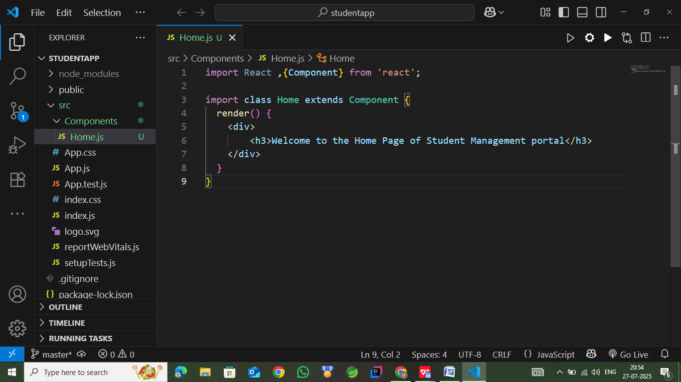

**Step 4**. Repeat the same steps for Creating “About” and “Contact” component by adding a new file as ”About.js”, “Contact.js” under “Src” folder and edit the code as mentioned for “Home” Component.

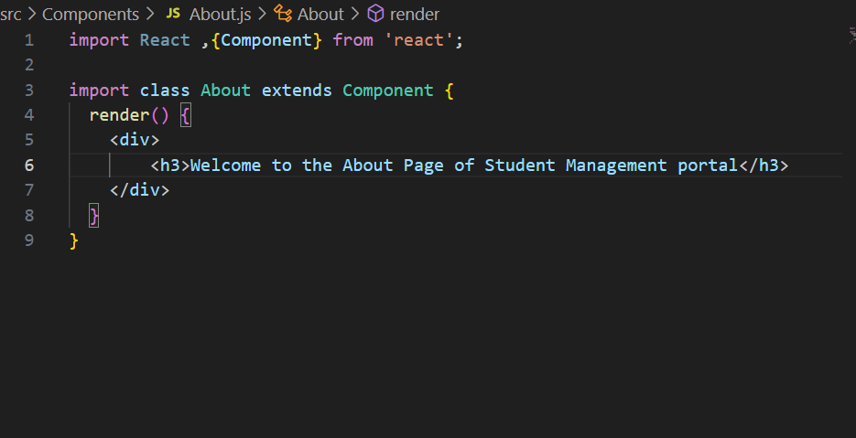

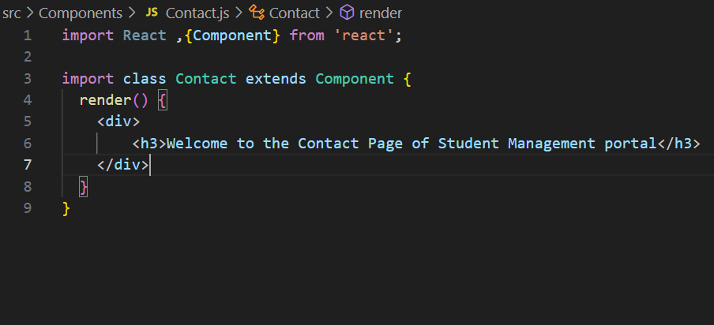

All of these syntax are of old react version and will give error so you will have to change the syntax a bit

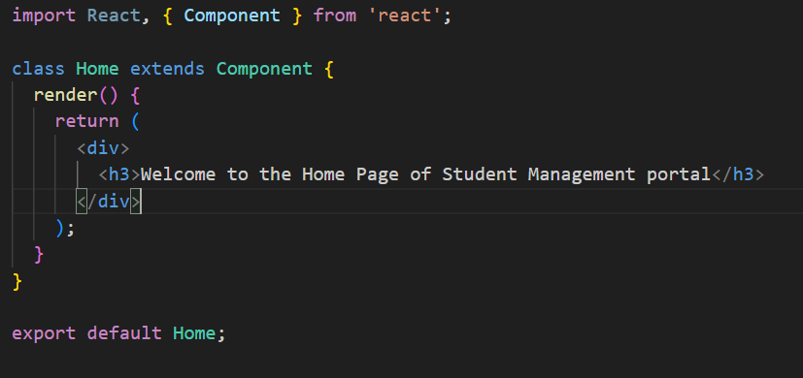

Make sure all the three files are written like this.

**Step 5.** Now Add the component to app.js file using the following code.

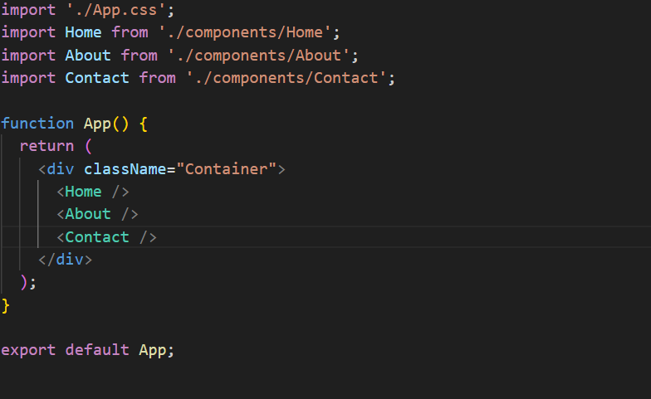

**Step 6.** Now start the server using **“npm start”** command

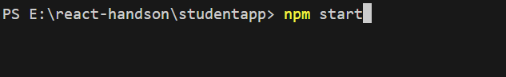

**Step 7.** It should show an output like this:

